Project Design Phase — Solution Architecture Report
Implement Client Script & UI Policy (Incident)
01 October 2026 | Project Design Phase | SWTID-2026-4755
Field | Project value
Date | 01 October 2026
Team ID | SWTID-2026-4755
Project Name | Implement Client Script & UI Policy (Incident)
Design focus | Define layers, responsibilities, control flow, boundaries, and verification architecture
1. Architecture objective
Place the business rule at the ServiceNow Incident experience where the user action occurs, while keeping data persistence, auditability, and authorization within the platform. The architecture must distinguish user guidance from security enforcement: client controls improve form quality; roles, ACLs, and server-side policies remain authoritative.
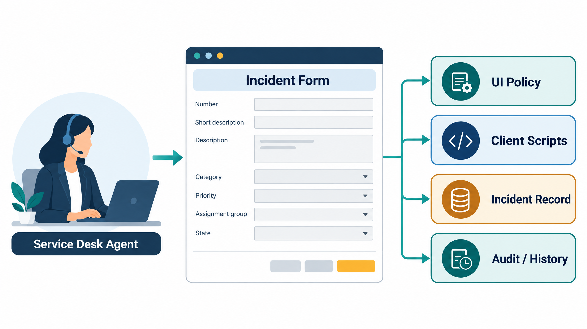
Generated architecture visual: Service Desk Agent → Incident Form → UI Policy / Client Scripts → Incident Record → Audit / History.
2. Logical layers
Layer | Component | Responsibility | Boundary
Experience | Incident form and Incident list | Capture values, show field states, display messages. | User interaction only.
Policy | High Impact Control UI Policy | Evaluate Impact = High; apply and reverse temporary field behavior. | UI state control.
Event logic | onChange, onSubmit, onCellEdit | Automate Urgency, validate ownership, reject unsafe list edit. | Client event processing.
Data | Incident table | Persist valid Impact, Urgency, group, owner, State, and description. | Operational record.
Governance | History, reporting, roles, ACLs | Support audit, SLA/reporting, and authorization. | Platform governance.
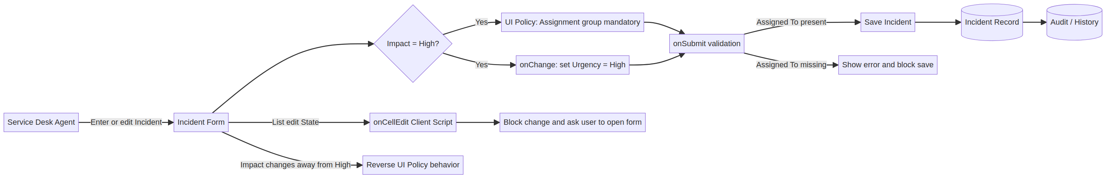
Generated deterministic data-flow diagram showing valid-save and blocked-action paths.
3. Data and control flow
Flow | Input | Control decision | Output
High-impact form entry | Impact = 1 | UI Policy condition true. | Assignment group mandatory; Urgency controlled.
Impact change | newValue = 1 | onChange script checks loading/blank and value. | Urgency set to 1; info message.
Form submission | Impact + Assigned To | onSubmit checks high impact and empty owner. | Return false with error or return true.
List State edit | sysIDs/table/oldValues/newValue | onCellEdit intercepts the edit. | Alert and callback(false).
Reverse transition | Impact changes away from 1 | UI Policy reverse-if-false. | Temporary actions revert.
Valid update | Validated form data | Platform saves record. | Incident record and history updated.
4. Configuration responsibilities
Object | Required configuration | Verification
UI Policy | Name High Impact Control; Table Incident; Active; Impact is 1 – High; Reverse if false. | Policy activates only under the target condition.
Assignment group action | Mandatory = true. | Field cannot be left empty when active.
Urgency action | Read-only = true; Visible unchanged. | Urgency visible but controlled.
onChange script | Table Incident; Type onChange; Field Impact; Active. | Urgency updates on Impact change.
onSubmit script | Table Incident; Type onSubmit; Active. | Invalid save is blocked.
onCellEdit script | Table Incident; Type onCellEdit; Field State; Active. | List edit is rejected.
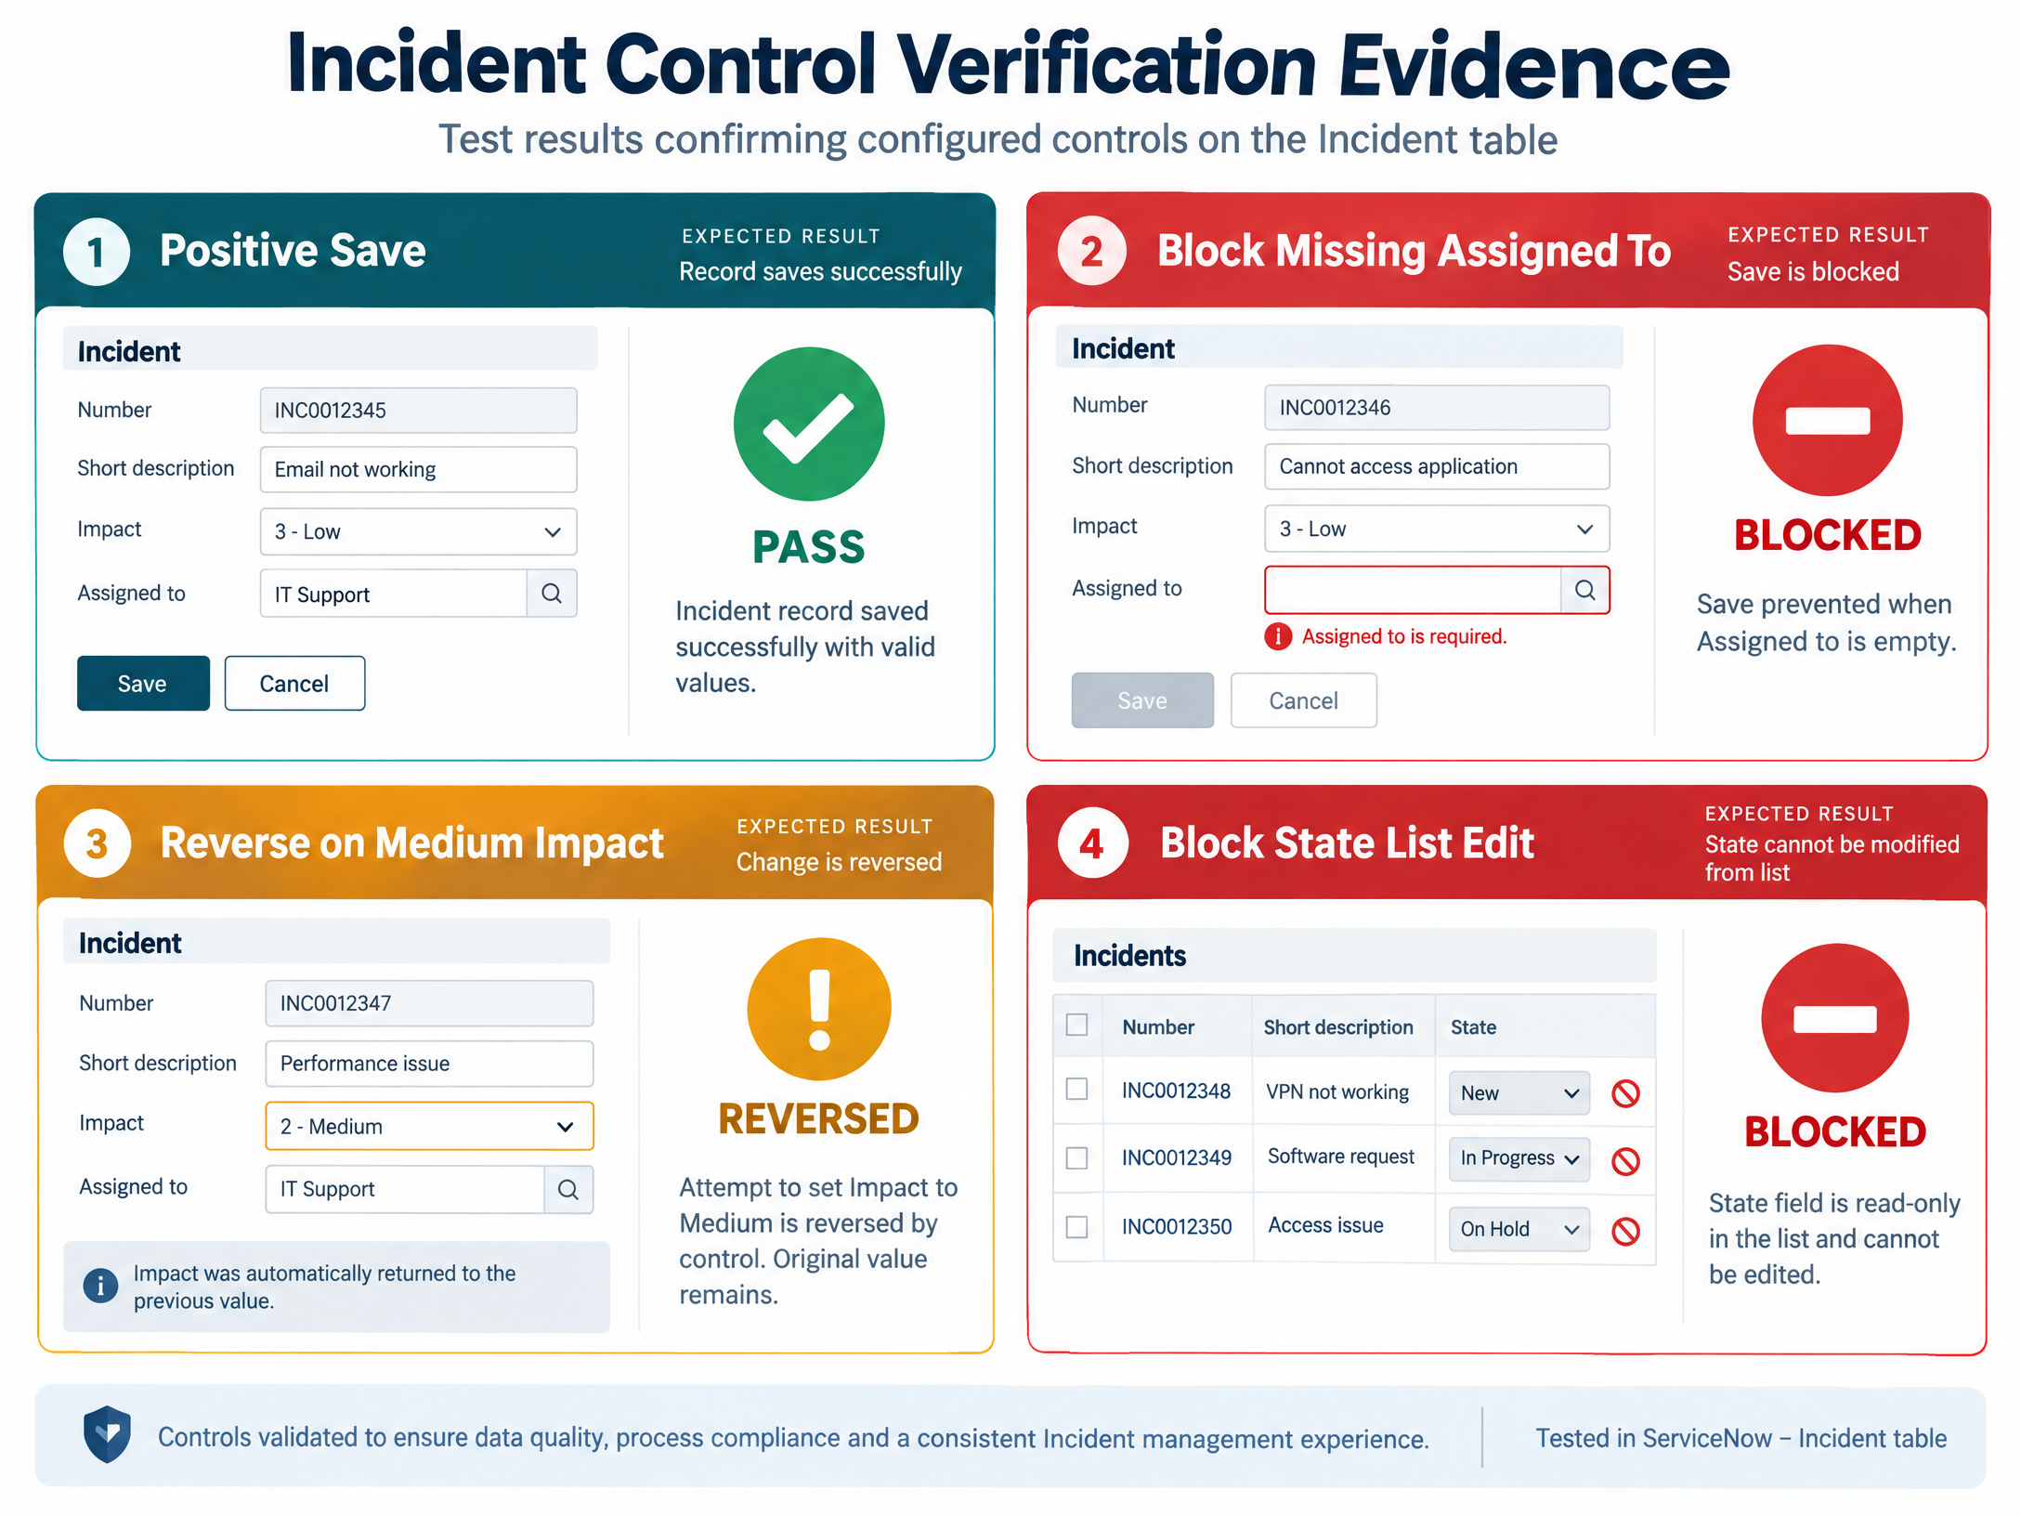
Generated project visual: new test-evidence view for architecture verification.
5. Sequence of a high-impact save
1. Agent opens Incident and selects Impact = High.
2. UI Policy condition evaluates true.
3. Assignment group becomes mandatory and Urgency becomes read-only.
4. onChange sets Urgency to High and explains the update.
5. Agent submits; onSubmit checks Impact and Assigned To.
6. If Assigned To is empty, showErrorBox returns false and no save occurs.
7. If the record is complete, the platform saves the Incident and native history is updated.
6. Security and operational boundaries
• Client-side scripts can be bypassed by integrations; add server-side equivalents if external writes must be governed.
• Do not treat the UI Policy as an authorization control.
• Use test data and authorized roles in non-production environments.
• Document field names and choice values because script behavior depends on them.
• Keep user messages actionable and avoid exposing sensitive data.
7. Verification architecture
Verification area | Test
Policy activation | Set Impact High; inspect mandatory/read-only states.
Automation | Change Impact to High; confirm Urgency and info message.
Negative save | High impact + empty Assigned To; confirm save blocked.
Positive save | High impact + Assigned To; confirm save succeeds.
Reversal | Change High to Medium; confirm normal behavior.
List protection | Attempt State list edit; confirm value unchanged.
Form update | Change State through form; confirm valid update.
8. Architecture conclusion
The architecture is intentionally platform-native and layered. The Incident experience supplies the touchpoint, UI Policy supplies conditional state, Client Scripts supply event behavior, the Incident table supplies the record, and ServiceNow governance supplies audit and authorization. This separation keeps the solution explainable and maintainable.

